**Database Architecture:**

A Database Architecture is a representation of DBMS design. It helps to design, develop, implement, and maintain the database management system. A DBMS architecture allows dividing the database system into individual components that can be independently modified, changed, replaced, and altered. It also helps to understand the components of a database.

A Database stores critical information and helps access data quickly and securely. Therefore, selecting the correct Architecture of DBMS helps in easy and efficient data management.

**Types of DBMS Architecture**

1-Tier Architecture

2-Tier Architecture

3-Tier Architecture

**1-Tier Architecture**

1 Tier Architecture in DBMS is the simplest architecture of Database in which the client, server, and Database all reside on the same machine. A simple one tier architecture example would be anytime you install a Database in your system and access it to practice SQL queries. But such architecture is rarely used in production.

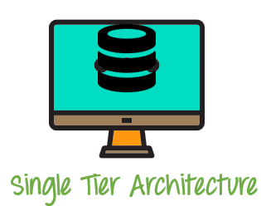

## 2-Tier Architecture

A 2 Tier Architecture in DBMS is a Database architecture where the presentation layer runs on a client (PC, Mobile, Tablet, etc.), and data is stored on a server called the second tier. Two tier architecture provides added security to the DBMS as it is not exposed to the end-user directly. It also provides direct and faster communication.

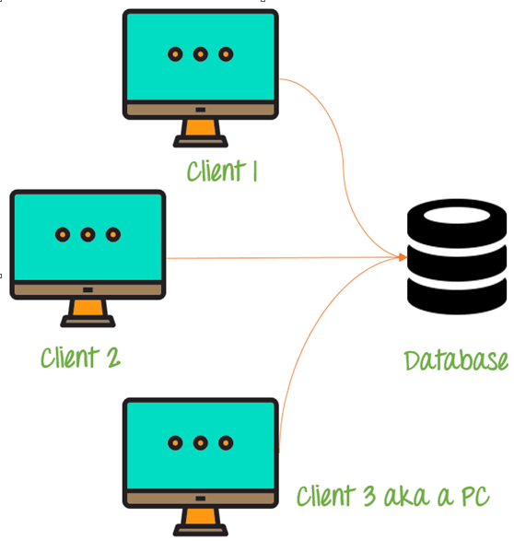

**3-Tier Architecture**

A 3 Tier Architecture in DBMS is the most popular client server architecture in DBMS in which the development and maintenance of functional processes, logic, data access, data storage, and user interface is done independently as separate modules. Three Tier architecture contains a presentation layer, an application layer, and a database server.

A 3-tier architecture has the following layers:

1. Presentation layer (your PC, Tablet, Mobile, etc.)
2. Application layer (server)
3. Database Server

